**DAILY ONLINE ACTIVITIES SUMMARY**

|  |  |  |  |  |  |  |  |  |
| --- | --- | --- | --- | --- | --- | --- | --- | --- |
| **Date:** | **23/06/2020** | | | | | **Name:** | **POOJA D S** | |
| **Sem & Sec** | **4th Sem 'B' Section** | | | | | **USN:** | **4AL18CS056** | |
| **Online Test Summary** | | | | | | | | |
| **Subject** | | **…….** | | | | | | |
| **Max. Marks** | | **…….** | | **Score** | | | **……** | |
| **Certification Course Summary** | | | | | | | | |
| **Course** | **Introduction to Information Security** | | | | | | | |
| **Certificate Provider** | | | **Great Learning Academy** | | **Duration** | | | **5.5 hour** |
| **Coding Challenges** | | | | | | | | |
| **Problem Statement:** A user will input two strings, and we find if one of the strings is a sub sequence of the other. Program prints “yes” if either the first string is a sub sequence of the second string or the second string is a sub sequence of the first string. Assume that, the length of the first string is smaller than or equal to the length of the second string. Assume that, the length of the first string is smaller than or equal to the length of the second string. | | | | | | | | |
| **Status: completed** | | | | | | | | |
| **Uploaded the report in Github** | | | | | **yes** | | | |
| **If yes Repository name** | | | | | <https://github.com/dspooja/C-coding>  <https://github.com/dspooja/Java-coding> | | | |
| **Uploaded the report in slack** | | | | | **yes** | | | |

Online Test Details: (Attach the snapshot and briefly write the report for the same)

Certification Course Details: (Attach the snapshot and briefly write the report for the same)

Coding Challenges Details: (Attach the snapshot and briefly write the report for the same)

ONLINE TEST DETAILS:

In Our College Organized by department of CSE Conduct Webinar on IOT, Cybersecurity and Company Specific training are the topics. And they Conduct IOT Webinar Quiz.

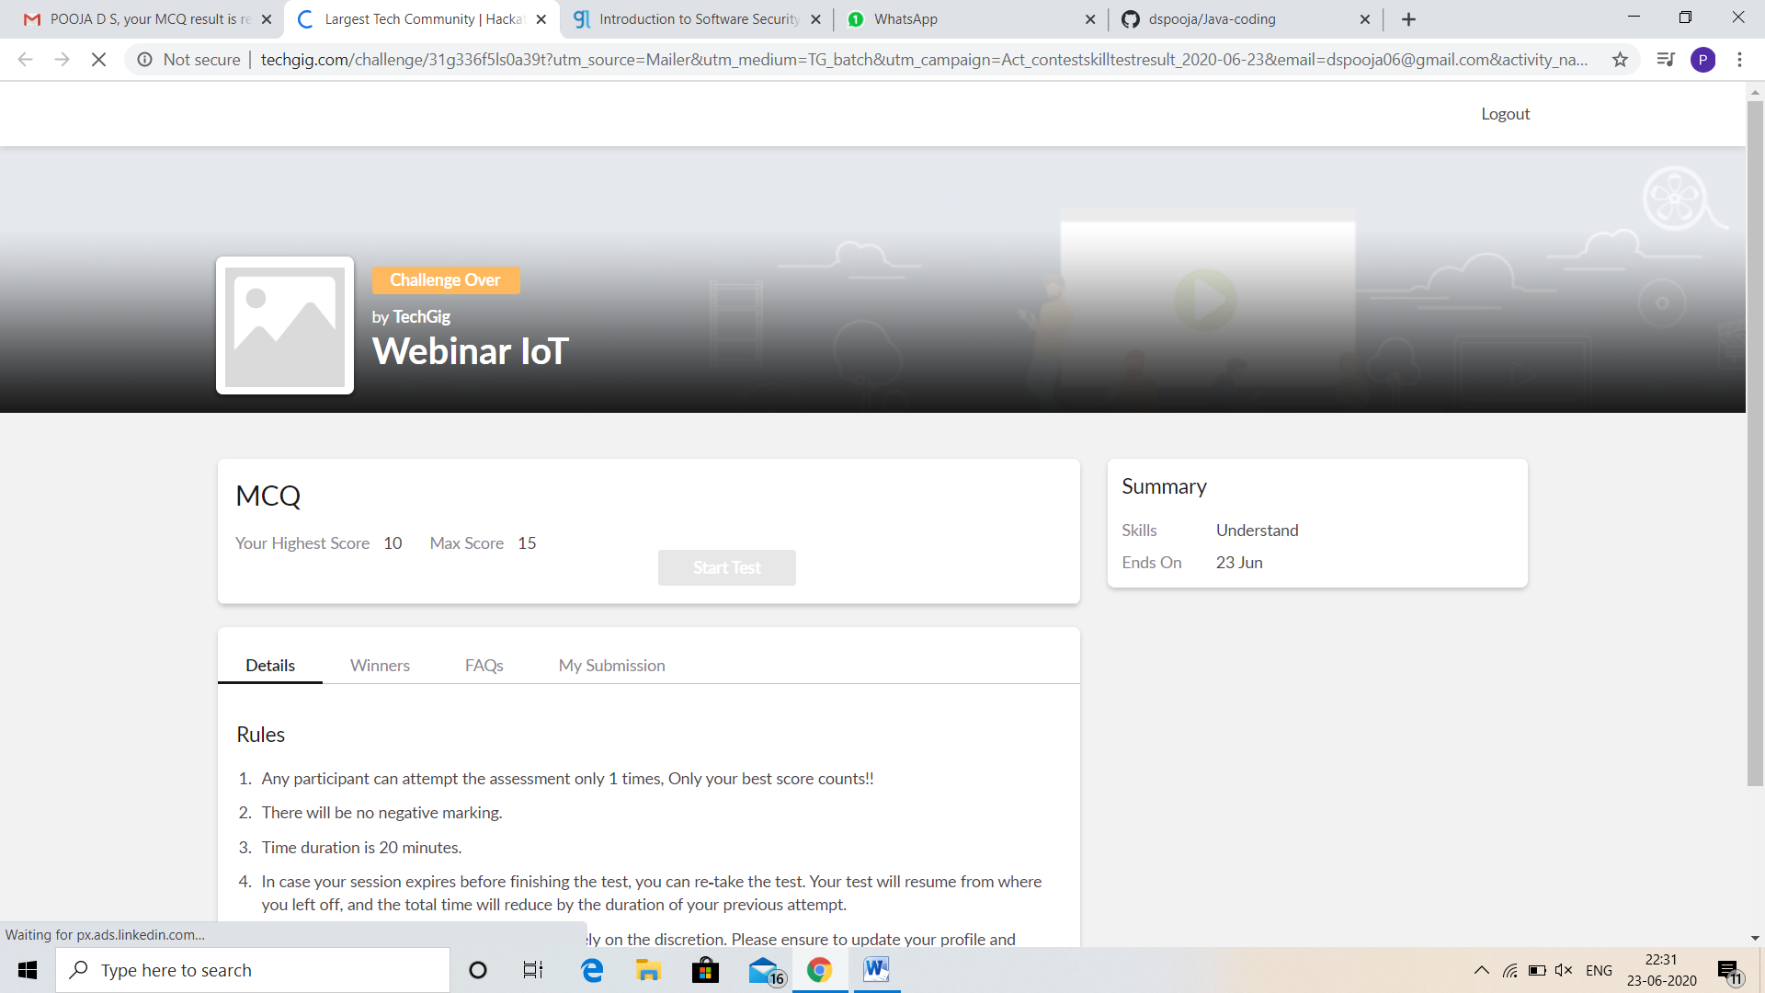

CERTIFICATION COURSE DETAILS:

* My Certification Course is Introduction to Information Security.
* **The concepts covered in** Introduction to Information Security **are:**
* Introduction to Software Security Lesson 2

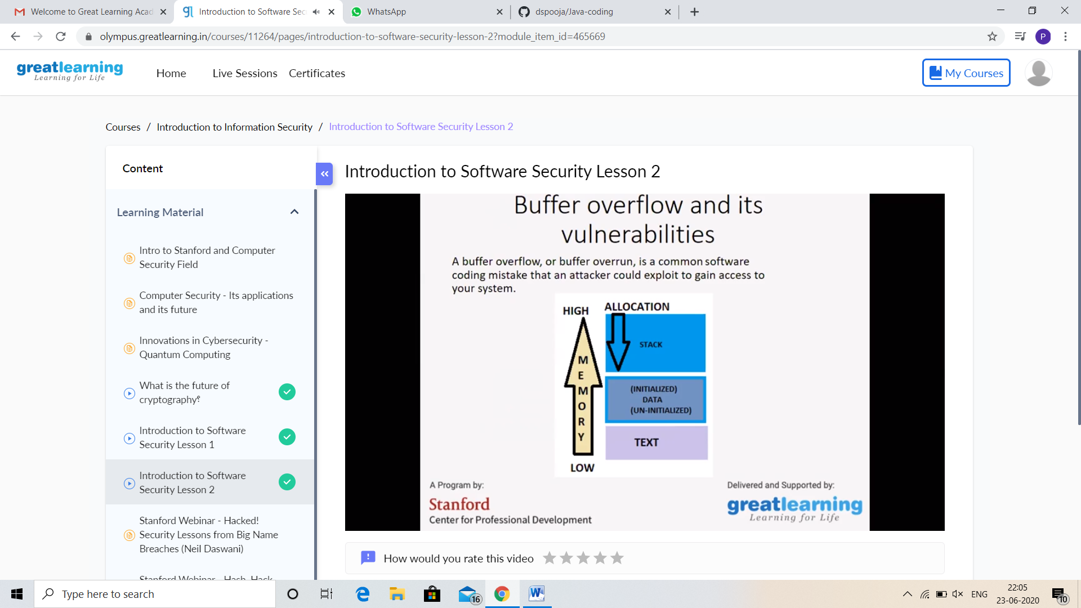

And I Participation in the Math E-Quiz. I got good Experience. And this is my certificate

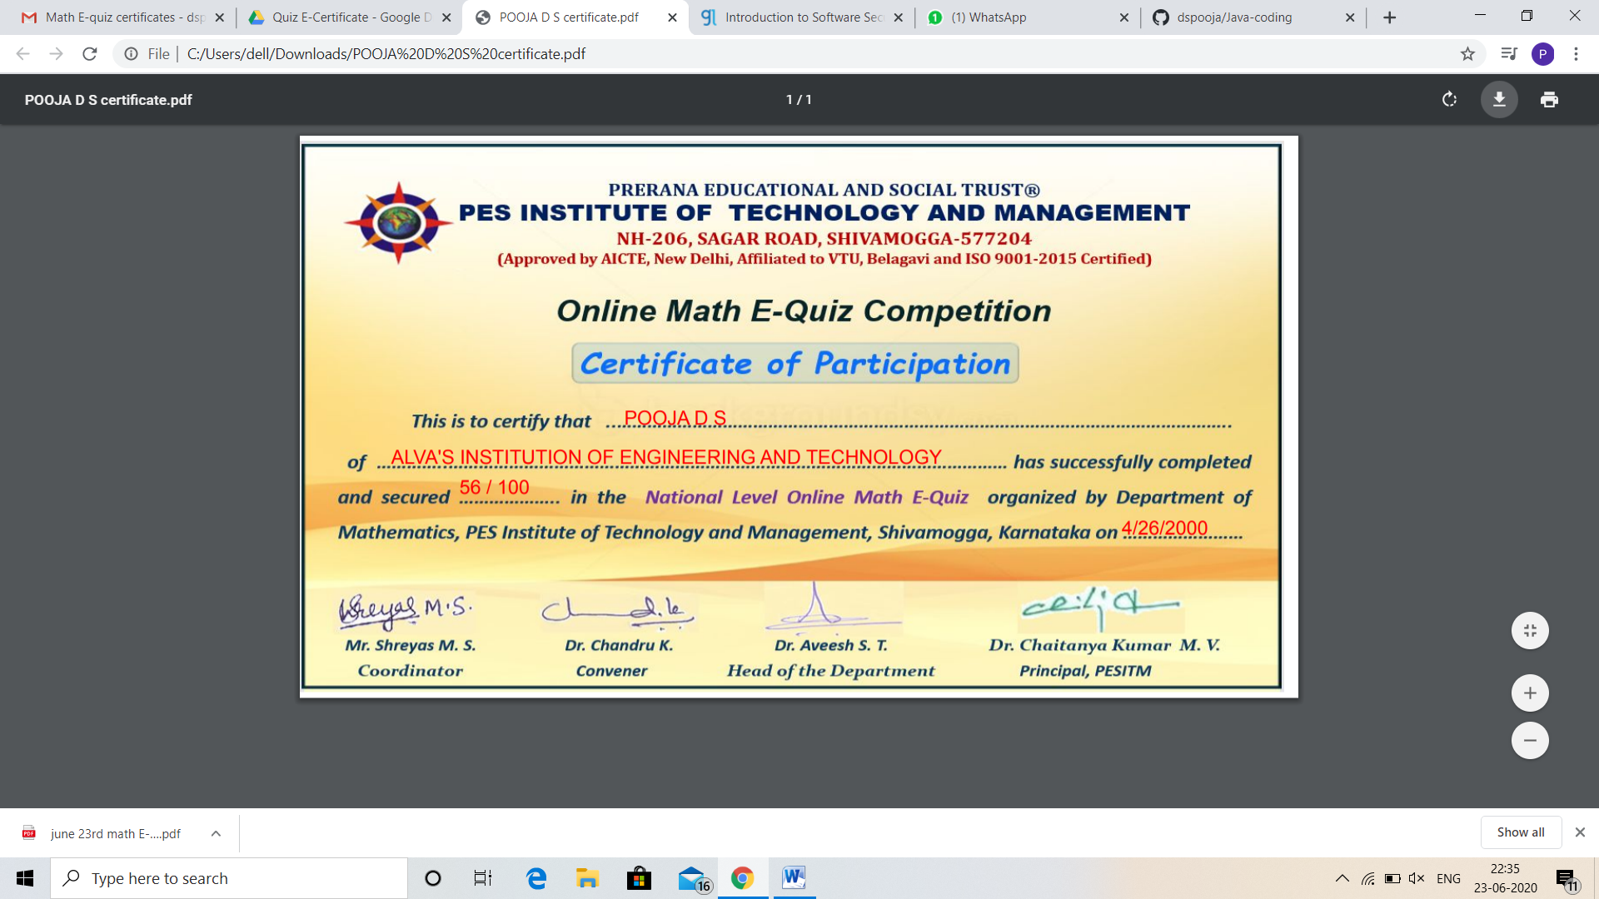

CODING CHALLENGES DETAILS:

Problem statement 2:

Write a C Program to Sort a stack using a temporary stack.

Solution: Uploaded in github.

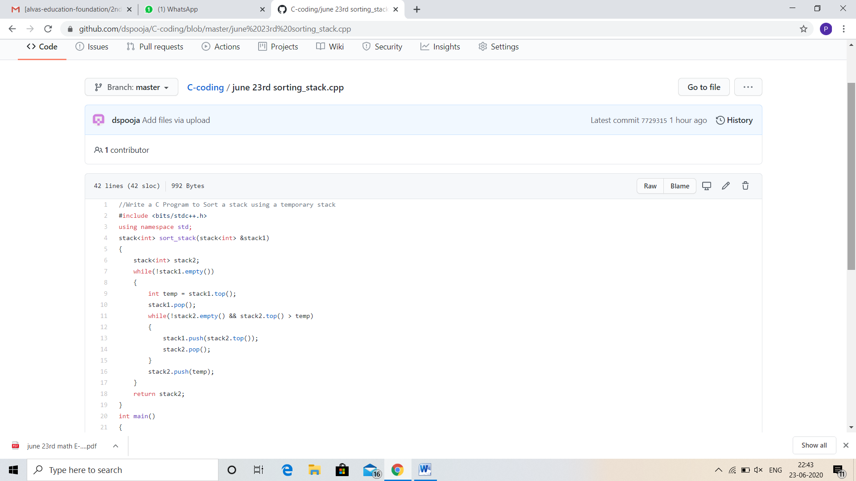

Problem statement 2:

Python Program to Split the array and add the first part to the end There is a given an array and split it from a specified position, and move the first part of array add to the end.

Examples:

Input: arr[] = {12, 10, 5, 6, 52, 36}  
k = 2  
Output : arr[] = {5, 6, 52, 36, 12, 10}  
Explanation : Split from index 2 and first  
part {12, 10} add to the end .

Input : arr[] = {3, 1, 2}  
k = 1  
Output : arr[] = {1, 2, 3}  
Explanation : Split from index 1 and first  
part add to the end.

Solution: Uploaded in github.

